**BONAFIDE CERTIFICATE**

This to certify that the report entitled

### An eCommerce shopping website

being submitted to the University of Madras, Chennai.

**By**

**V.T AJAY**

(Reg.No. No:811850046)

for the portal fulfilment for the award of degree of

**MASTER OF COMPUTER APPLICATIONS**

Is a bonafide record work TCried out by him under the guidance and supervision.

Date:

**Mr. D. RAVANDOSS.,** M.c.A.,M.Phil.,

Assistant Professor, Department of Computer Applications, Jaya College of Arts and Science, Thiruninravur-602 024.

Submitted for the viva-voice examination held on

**Internal Examiner External Examiner**

**DECLARATION**

### This is to certify that the project entitled **"AAn eCommerce shopping website”**

submitted to the University of Madras in partial fulfillment of the requirements for the degree of **MASTER OF COMPUTER APPLICATIONS** is a record of original main project work done by me, under the guidance and supervision of **Mr. D. RAVANDOSS.,M.C.A.,M.Phil. Assistant Professor,** Department of Computer Applications, Jaya College of Arts & Science, Thiruninravur - 602024, and it has not form the basis for award of degree nor similar title to any candidate of any university.

**V.T AJAY**

Reg.No:- 811850046 MASTER OF COMPUTER APPLICATIONS, JAYA COLLEGE OF ARTS AND SCIENCE,

THIRUNINRAVUR - 602024.

# ACKNOWLEDGEMENT

The Project work cannot be a one-man show. Although it is impossible to give individual thanks to all helpful faculty members and to those in connection. I take this opportunity to express my gratitude for them.

As a start, my heartfelt thanks to God for giving his blessing and confidence to make this project a successful one.

I feel grateful to thank **Prof. A.KANAGRAJ, M.A.,M.Phil.,** Founder and Chairman, Jaya Educational Trust, **Mrs. K. VIJAYAKUMAI.M.A.,B.ED.,** Secretary,Jaya EducationalmTrust, and **Mr. K. NAVARAJ,M.E.,** Vice Chairman,Jaya Educational Trust for extending their support during course of my studies .

I am grageful to **Dr. P.GUHAN, M.C.A., M.Phil., Ph.D.,** prin cipal, Jaya College of Arts and Science, Thiruninravur - 602 024, for providing me with an environment to complete my project successfully.

I take pleasure in thanking **Mrs. S. Cynthia Juliet.,M.C.A.,M.Phil. Head Of The Depertment(i/c),** Department of Computer Applications, Jaya College of Arts and Science, Thiruninravur, for extending his support throughout the main project.

I would also thank my Institution and faculty members without whom this project would have been a reality.

By

# V.T DHAMODARAN

(Reg. No.: 811850046)

### An eCommerce shopping website

**INDEX**

|  |  |  |
| --- | --- | --- |
| S.No. | CONTENTS | Page No. |
| 1 | **ABSTRACT** | 05 |
| 2 | **SYSTEM ANALYSIS AND DESIGN** | 07 |
|  | 2.1 Existing System |  |
| 2.2 Proposed System |  |
| 2.3 Hardware Requirements |  |
| 2.4 Software Requirements |  |
| 3 | **PROJECT DESIGN** | 21 |
|  | 3.1 Data Flow Diagram |  |
| 4 | **TABLE DESIGN** | 31 |
| 5 | **SCREEN DESIGN** | 35 |
| 6 | **REPORT** | 45 |
| 7 | **CODE NIPPETS** | 46 |
| 8 | **SYSTEM TESTING** | 58 |
| 9 | **CONCLUSION** | 70 |
| 10 | **BIBLIOGRAPHY** | 71 |

**ABSTRACT**

The thesis aimed to develop an online shop using open source technologies (PHP, HTML5, CSS3, JavaScript, MySQL and Apache Web Server) for electronics products in Ghana where customers will be able to buy products online. The designed application will have an admin view and the public or guest view.

The admin view is meant for the administrator to update the products, change prices, remove and add products and also manage customers.

The customer view will be accessible to the customers, and they will be able to handle their information such as their name, address, and contact. Also, the customer will be able to order for products from the shop.

commerce (electronic commerce or EC) is the buying and selling of goods and services, or the transmitting of funds or data, over an electronic network, primarily the internet. These business transactions occur either as business-to-business, business-toconsumer, consumer-to-consumer or consumer-to-business.

E-commerce shops have become part of our daily lives. Technological advancement has made it possible for people to sit in the convenience of their homes and still shop online without going to a physical shop. Africans have also joined the trend of e-commerce business, so this project is meant to design an eCommerce online shop so that the people in Ghana (Africa)will be able to purchase their goods and services online.

This project is mainly divided into two main categories: The Administrators and the Customers/Users.

The store manager and the staff members operate as the administrators. They can add, edit, update products or, delete products thus they able to change the names of products, change prices and, add or remove products. The customer can search for products selection, update the cart, remove products from the cart and check out from the shop.

The customer is also able to update his information such as names, address and other data. The User is only able to browse the online shop and add a product to the cart. The user is limited to the use of the shop. This thesis contains eight chapters to explain the project.

The first chapter introduces the project; the second chapter defines the tools and technology used for the project, and the third chapter describes the application and description of the process.

The fourth chapter represents the MVC layout, the fifth defines the database and the Gui designs, the sixth chapter explains the implementation process,and the seventh chapter describes the testing of the shop and its features,the eight chapter describes the conclusion of the whole project.

The ninth chapter illustrates possible future improvement to the shop.

# SYSTEM ANALYSIS AND DESIGN

* 1. **Existing System**

Although online product recommendation has been constructing solutions within certain e-commerce websites

To recommending products from e-commerce websites to users at social networking sites who do not have historical purchase records, i.e., in "cold-start" situations.

It mainly utilize users' historical transaction records.

## Proposed System:

Customer interface and administrator interface are the main interfaces created in this project. With the customer and admins interface, I used HTML5 and CSS3. The HTML5 was used to create the structure of the page whiles the CSS was used to style the page.

PHP is a dynamic language,so I used it to automatically fetch information from the database unto the web pages without rewriting every data by hand.

The customer can only check out if he has logged in as a customer. Without being a customer, he is unable to checkout successfully.

To affirm the online store assessments had been made at distinct stages of the task; I checked the reliability of all of the functions. The test is built on the customer/user and Management Unit. The customer test proved that an account could be created, login can be established, the cart can be loaded with products and the customer can check out when done shopping. The administrator can create an account and log in afterward. The admin can then manage all the content in the shop.

The user is expected to provide the necessary information. Any missing space or wrong information may lead to the customer not being able to register.

### Hardware Requirements:

System :- Pentium IV 2.4 Ghz.

HardDisk :- 80 GB.

Monitor :- 15 VGA Colour.

RAM :- 2 GB

*Basic Configuration System/Laptop.

* 1. **Software Requirements:**

Operating System :- Windows 10.

Front End:- Xampp. HTML, Css, JQuery, JS

Coding Language :- PHP,AngularJS,Jquery.

DataBase:- MySQL.

SCM:- GitHub

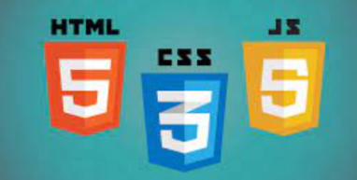 

 

### Software Description:

**HTML**

HTML means Hypertext Markup Language. This language is used in creating web pages. This language also supports other languages such CSS, PHP, JAVASCRIPT, etc. in creating interactive and responsive pages on the pages. HTML5 is just an updated version of the HTML. It supports new features, new attributes, new HTML elements, full CSS3 support, video and audio, 2D/3D graphics that help users and also help web developers to create new features easily on the website

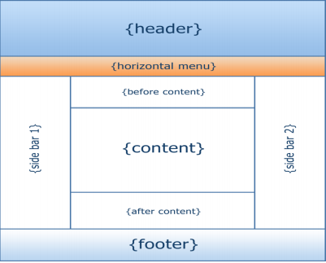

**CSS**

CSS 3 CSS is simply referred to as Cascading Style Sheets.CSS is used to define styles for web pages, including the design, layout, and variations in the display for different devices and screen sizes./3/ The general structure of CSS Basic syntax

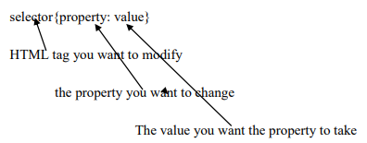:

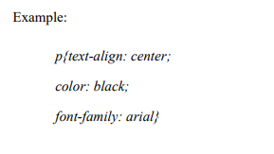

**JAVASCRIPT**

Javascript is a high-level language which could be used independently or inculcated into the webpage. It can be used to, handle requests and responses and also add dynamic behavior and also store information on a website.

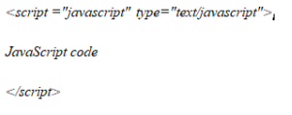

**MYSQL**

MySQL is a free source database system, and it enables the cost-effective delivery of reliable and a high-performance and scalable Web-based and embedded database applications. It is a relational database system(RDBMS). It is a high performing program and scalable to meet the demands of users and data. MySQL is written in C and C++, so it is compatible with most of the operating systems available around the world

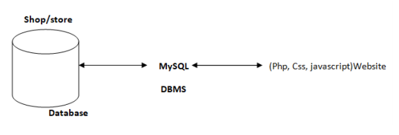

**UML:**

UML (Unified module language)UML. It is used for constructing and documenting a system or a project. This is widely used by people such as engineers to make module structures of what they want to build

**XAMPP**

XAMPP is an integrated development surrounding, which incorporates Apache HTTP Server, MySQL Database, and PHP, Mercury, PERL or Python on a home Windowsbased computer. Apache is a free web server. MySQL is an open source database. XAMPP is used in collaboration with, PHP, MySQL and, Windows 8 operating system./

**Bracket(Editor)**

Brackets is a free-source editor written in HTML, CSS, and JavaScript. It is created via Adobe structures, certified underneath the MIT License, and is presentlymaintained on GitHub. Brackets are compatiblewith Mac, Windows, and Linux operating system

**PhpMyAdmin**

PhpMyAdmin is a free and open source MySQL managementprogram applicationwritten in PHPand was first launched in 1998 under the GNU preferred Public License. It is cross-platform help for the essential working structures and helps management of more than one servers. It supports most MySQL capabilities and has an intuitive net interface. It additionally has supports developing PDF graphics of database layout, importing information from CSV and SQL formats as well as exporting records to various codecs such as SQL, XML, PDF and, CSV.

**Administrators Detailed Attribute**

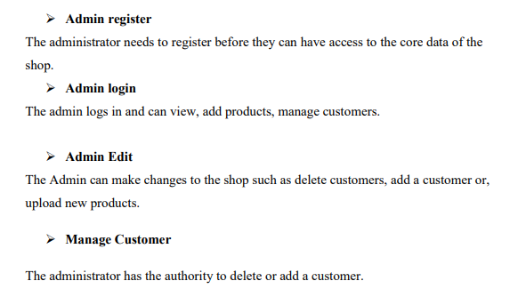

**Overview of PHP:**

PHP (recursive acronym for PHP : Hypertext Preprocessor) is a widely-used open source general-purpose scripting language that is especially suited for web development and can be embedded into HTML.

PHP is a server-side scripting language, especially suited for the creation of dynamic web pages. This programming language offers web developers a large selection of instruments. PHP, which has become the basis for many web applications, allows easy insertion in HTML code and connection to MYSQL and PgSQL Databases.

A PHP page must have a PHP-supported extension. Typically, a PHP file ends with .php, although other PHP extensions such as .php4 and .phtml also exist. However, .php is the most common extension.

* + 1. **PROCEDURES:**

### To create a new PHP page

Do one of the following :

* + - * On the File menu, point to New, and then click PHP.
      * On the File menu, click New. In the New dialog box, on the Page tab, click General, then click PHP, and then click OK.

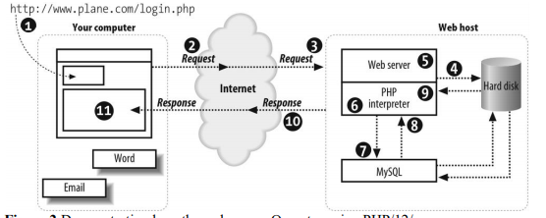

### PHP script blocks

* + - * A PHP script block can appear anywhere in a .php page, and each page can contain more than one PHP script block. A PHP script block must begin with <?php and end with ?>.
      * The following is an example of a PHP script block:

<?php

echo "Hello World";

?>

### 

### Features of PHP:

* Loosely Typed Language : PHP supports variable usage without declaring its data type. It will be taken at the time of the execution based on the type of data it has on its value.
* Cross Platform Compatibility : It is used to create the desktop application by using advanced PHP features.
* variable variables : PHP allows changing the variable name dynamically by using variable variables.
* Real-Time Access Monitoring : PHP provides access logging by creating the summary of recent accesses for the user.
* Magic Method : PHP has built in methods starts with (double underscore). These methods can’t be called directly. Rather, it will be called on the event basis.

For example, clone() will be called, when the clone keyword is used.

* Error Reporting : It has some predefined error reporting constants to generate a warning or error notice.

For example, when E_STRICT is enabled, a warning about deprecated methods will be generated.

* Extended Regular Expression : PHP provides REGEX methods with extensive parsing and pattern matching mechanism with remarkable speed.
* nowdocs and heredocs String : PHP provides the *nowdocs* and *heredocs* properties are used to delimit some block of context. *nowdocs* and *heredocs* are same except the context in the heredocs allow variable parsing.
* Traits : PHP is a single inheritance language. The traits concept is used to cover inheritance limitation and support inheritance at multiple levels.

##### Advantages of the PHP software development technology

The main factor of the PHP language is the practicality. This programming language gives the possibility of realization tasks in short period and high quality for the developers. This point is based on the 5 features:

* **Traditionality** : PHP programming language is rather easy for the developers that work in different spheres. It is based on C and Perl that minimized efforts for learning the **PHP software development** and HTML5 mobile web development main elements and functions. Simplicity : The PHP script could consist of 10000 symbols or even from the one line - all depends on the project requirements and development purposes. There is no necessity for additional libraries download or specific compilation points mentioned.
* **Effectiveness** : The important advantage of the PHP language is its software engine. It is not just a compiler or interpreter, it is the relaying interpreter. Such structure of the software engine makes possible of high-speed script process.

### Security of PHP software development process

* Security : **PHP software development** process gets two security categories for developers and administrators: system-level services and application-level tools. System-level is guaranteed by the safe mode work type that limits the user’s possibilities in different points.
* Application-level is realized through the standard function set with the number of strong encryption mechanisms.
* Flexibility : **PHP software development** language is easy integrated with HTML, JavaScript, XML etc.

##### 

##### Advantages of PHP

* **Open source** : It is developed and maintained by a large group of PHP developers, this will helps in creating a support community, abundant extension library.
* **Speed** : It is relative fast since it uses much system resource.
* **Easy to use** : It uses C like syntax, so for those who are familiar with C, it's very easy for them to pick up and it is very easy to create website scripts.
* **Stable** : Since it is maintained by many developers, so when bugs are found, it can be quickly fixed.
* **Powerful library support :** You can easily find functional modules you need such as PDF, Graph etc.
* **Built-in database connection modules :** You can connect to database easily using PHP, since many websites are data/content driven, so we will use database frequently, this will largely reduce the development time of web apps.
* Can be run on many platforms, including Windows, Linux and Mac, it's easy for users to find hosting service providers.

##### Disadvantages of PHP

* Security : Since it is open sourced, so all people can see the source code, if there are bugs in the source code, it can be used by people to explore the weakness of PHP.

Not suitable for large applications: Hard to maintain since it is not very modular.

##### FRAMEWORK OF PHP:

PHP framework is a library that makes the life of site developer easier by for example hiding some complexities of HTTP protocol or by adding some useful functions. For example the **CakePHP** implements so called **MVC** which makes developer to think a level higher than HTTP.

##### USE OF FRAMEWORK:

The **MVC Pattern.** The Popular **PHP** frameworks like CakePHP, CodeIgniter, Zend Framework, Symfony follow Model View Controller(MVC) design pattern which separates business logic from user interface making the code cleaner and extensible.

Advantages of PHP Framework:

There have been multiple advantages of **PHP** framework, while developing a website with a **PHP framework**. Utilizing the PHP framework can encourage website developers to show their best efforts.

PHP framework inbuilt with **robust functions**:

This framework is built with an excellent set of functions, you can abridge tough tasks and get quick results from PHP coding. PHP framework is freeware with various functions; utilizing these functions you can simplify the code in PHP.

##### **Centralized Database:**

Database is the crucial factor for each project. It is the central point, where the entire data of the project are saved and called for, when required. MySQL is utilized for the database requirements for PHP.

##### Use wire-frame before coding:

It is always beneficial to use wire frame before you start coding in PHP. The practice of using wire-frame, boost your web development projects effectively. Make sure the wire-frame club and all its elements are integrated perfectly.

##### Disadvantages of PHP Framework:

Everything has two aspects. So, PHP framework has also some disadvantages Let's have a brief look of the disadvantages of PHP framework.Poor error handling method:

PHP framework has a bad error handling method! It is not an proper solution for the PHP developers. Therefore, as a qualified PHP developer, you will have to overcome with it.

##### **PHP is Unsecured:**

It is an open source system, so anyone can see and change the source code! If any web developers, who have great idea and experience in bug finding in the code can exploit your coding practice.

##### **Core PHP:**

It is very basic **PHP**. It is used to create dynamic web pages. It works without any additional library.

PROJECT DESIGN

Administrators Detailed Attribute

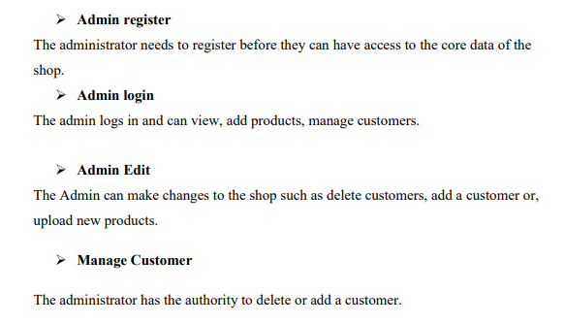

Customer Detailed Attribute

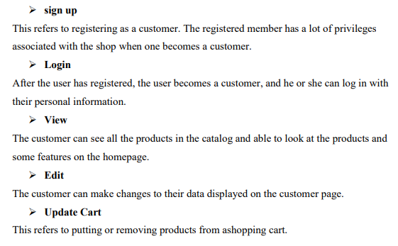

Data Flow Diagram:

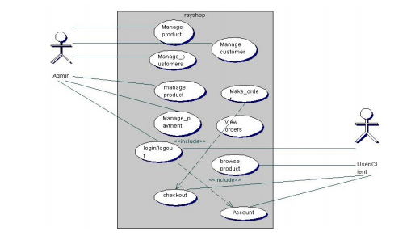

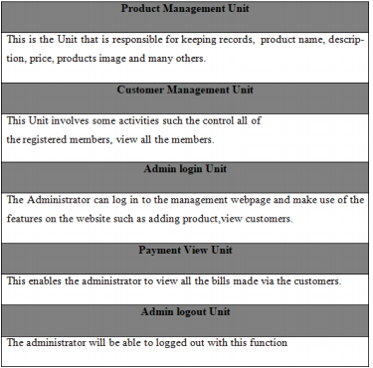

User registration

The Users will use their exclusive information to register.

After filling the form and submitting it, the html5 checks to see if all the fields entered by the user are 16 correct.

If the area is not correctly filled the user remains on the same pagebut if the requirements are met the data goesto the database (table "customers") and saves the information of the User.

The User then becomes a customer, and he or she is then directed to the login webpage of the shop.

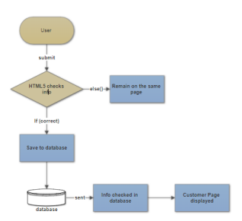

Customer login

The customer will use his particular data e-mail and passwordto log into the shop.

After submitting the form, the html5 checks if all the fields have been filled correctly.

If the condition is not met the customer remains on the same page but if the fields are correctly filled the customer login information is sent to the database to check if the data entered into the areas are same as the ones used to register to the database.

If it is correct, 17 the customer is redirected to his homepage, and he can successfully pick products and check out if they are done shopping. Figure 7 shows the flow diagram of customer login

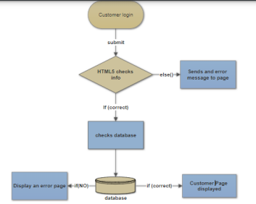

Administrator Registration

The Administrator will use his particular data such as name, e-mail, and password. After submitting the form, the html5 checks to see if all the fields entered by the adminis correct. If the filed are not correctly filed, or conditions are not met the admin remains on the same page but if all requirements are met admin's information goesto the database and saves the data in the "Admins" in the database. After that, the administrator is directed to the admin webpage to log in. The Figure 8 shows the administrator registration diagram.

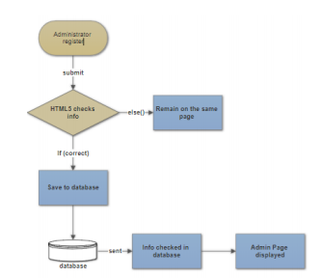

Administrator Login

When the admin logs into the Administrators webpage the html5 checks to see if conditions are met when logging in.

If all the information provided are correct, the data is sent to the database to check if the data corresponds to the information used to register.

If it matches to the information provided by the Administrator, a page opens, and the admin can have access to the administrator's webpage if not the administrator is restricted from having access to management webpage.

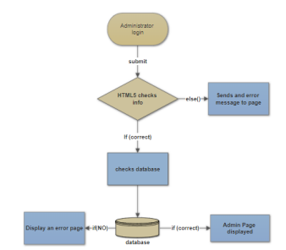

MVC UNIT OF SHOPPING CART:

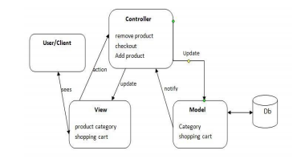

The three parts of the MVC software structure perform the following: View – shows the interface that the person sees (usually, a webpage).

The view additives provide records to the user and moves to the Controller for manipulating data. Model – defines the statistics for the software (typically, the facts is saved in a database(DB)).

The controller provides the interface between the View and the model.

Back-end Module layout

This includes Units such as products, brand, category, orders and, customer management modules.

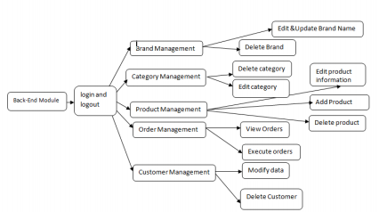

The back-end module/Unit is used to manage the backend of the shop. This is only available to the administrators.

They can manipulate the shop to suit the conditions they have set for the shop.

They also make sure that customers have a good experience when visiting the shop by updating products, deleting products, executing orders to warehouses, and managing customers

**TABLE DESIGN**

**DATABASE GUI DESIGN**

Design for database and GUI application

**Database**

MySQL database is used to save software data for this project.

MySQL is relational database management, and it is free of charge. All of the informationis kept in a selectedtable, and every table has particular range columns and rows. It has eight tables named as admins, brands, cart, categories, customers, orders, payments and products. the ER-diagram of the eight tables in the database.

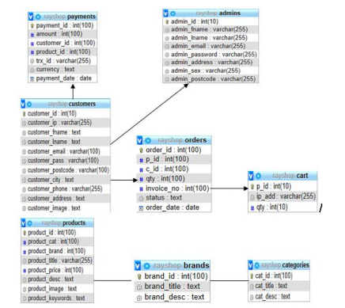

The ER-diagram has a specific name and it consists of columns and rows. For each table, we need to mark at the least one area as a primary key. The primary key is usually specified in a particular table. The table "admins" is created to store all the Admin’ information.

It consists of eight distinctive fields referred to as columns to shop admin id, first name, last name, email, and password.

The email and the password are essential because they are needed for one to login into the shop.

"admin_id" is the primary KEY. Many columns of one table may be described as primary KEY. Each column has a name, a datatype and different nonobligatory attributes.

only displays different brands of products, brand identity and also the descriptions of the multiple brands.

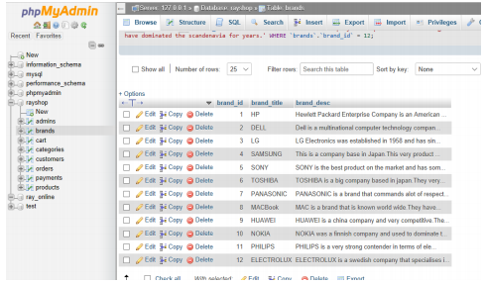

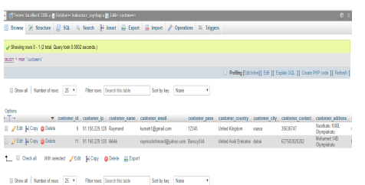

The customers who have registered to the online shop have their data automatically stored in the database.

This information is only available to the technical administrators. The administrator can delete, edit, and update customer information

**SCREEN DESIGN**

Consumer refers to customers and non-customers. These are individuals who visit the shop either to buy products or to browse.

There are two categories of interfaces namely the Consumer and the Administrator interface. The administrator has higher authority over the customer in the shop. The admin can edit, replace a product and, manipulate data in the shop. The customer can browse a product, add a product to the cart, change personal information, check shopping history and checkout or log out. The User, on the other hand, can only browse and add a product to cart.The homepage or interface is the index page of the shop so can be accessed when the address is typed into a browser. The web page has products images, names, prices, product categories and product brands. The web page has a registration link, login link, cart, company contact information.

POPUP Screen:

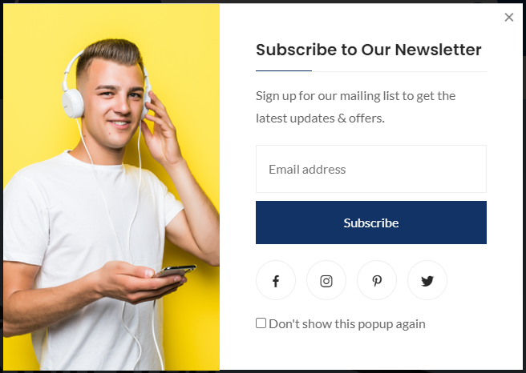

**About.US:-**

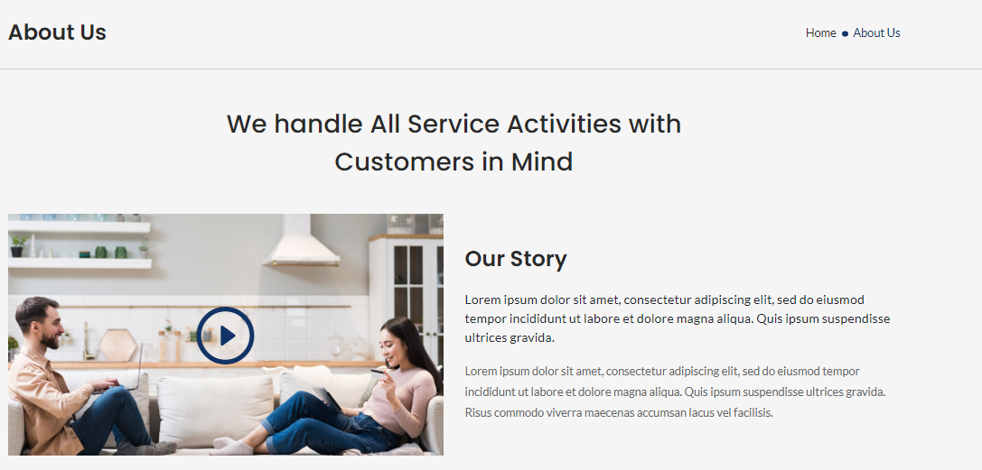

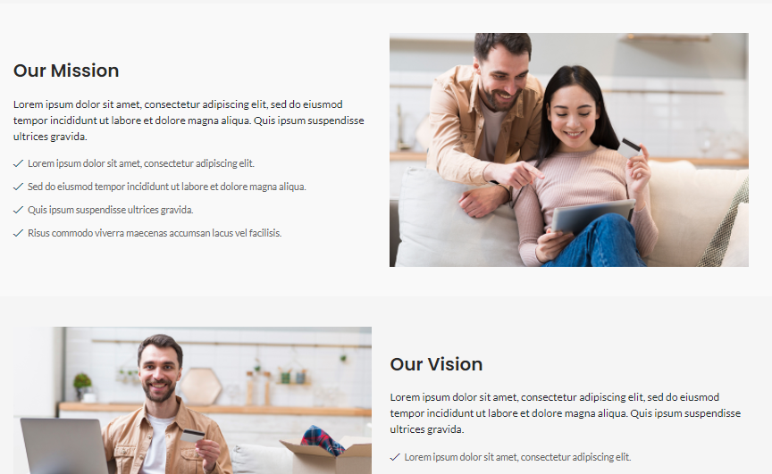

**BLOG:-**

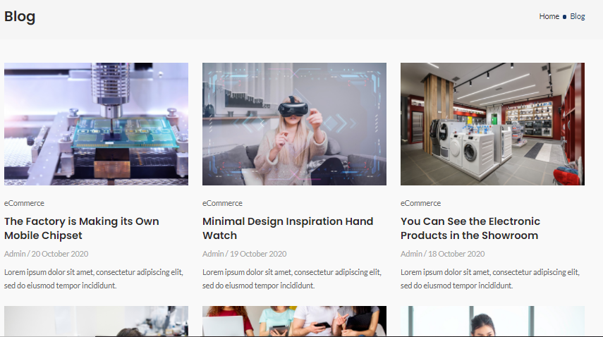



**CONTACT:**

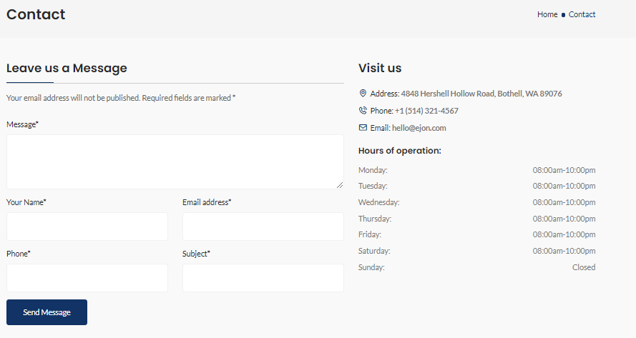

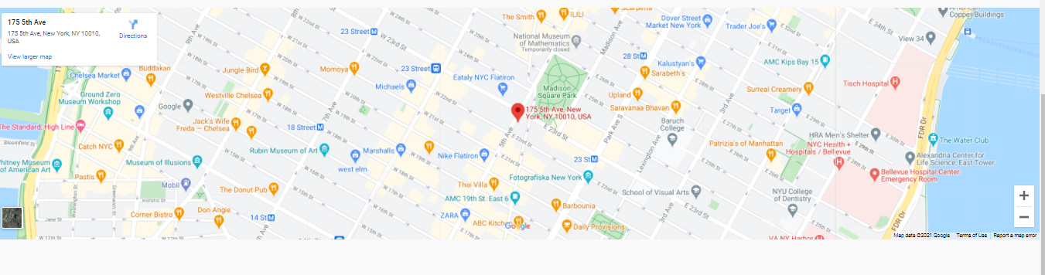

**ACCOUNT:-**

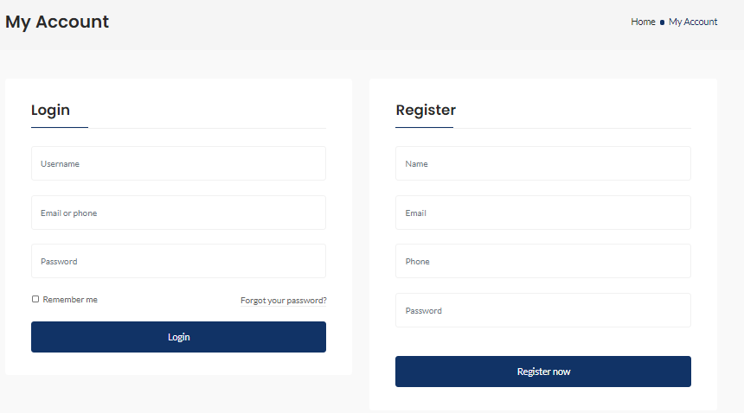

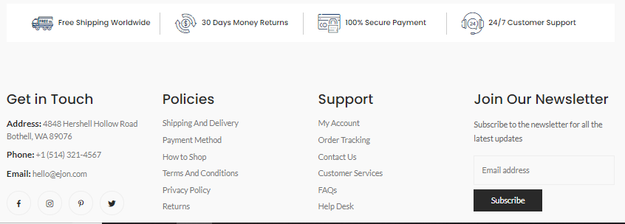

**SIDE MENU:**

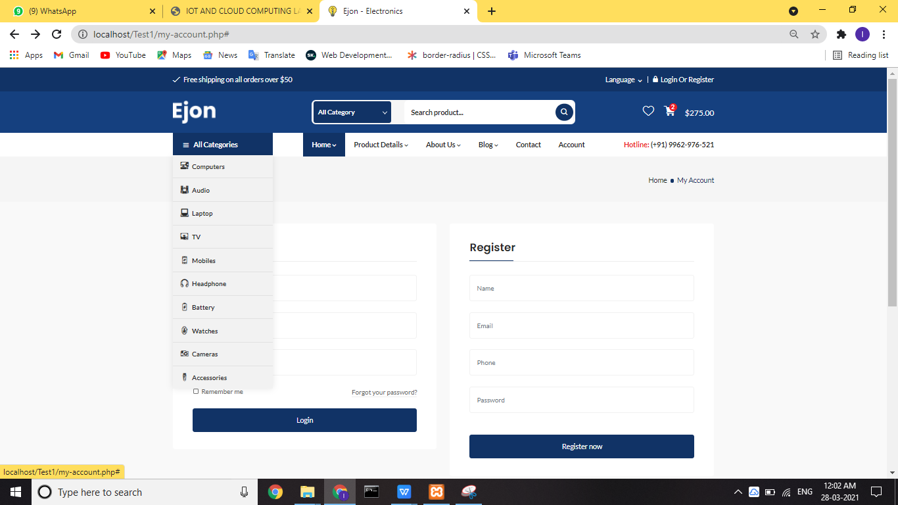



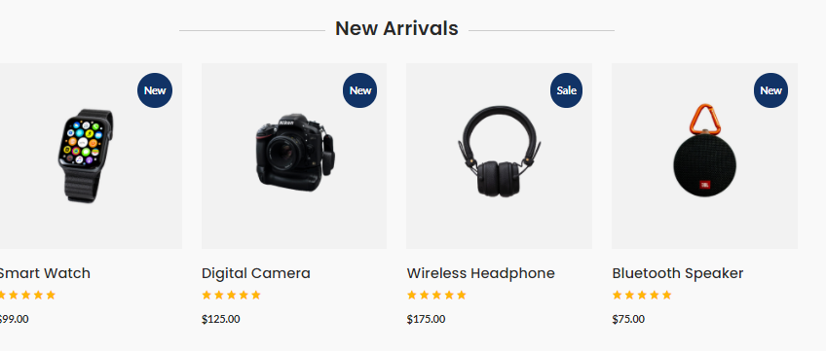

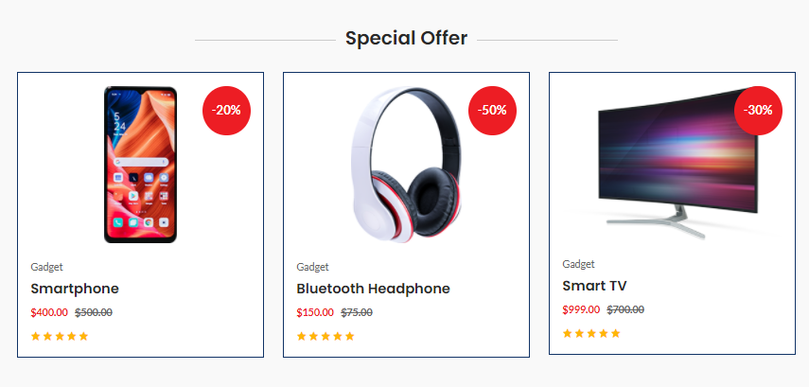

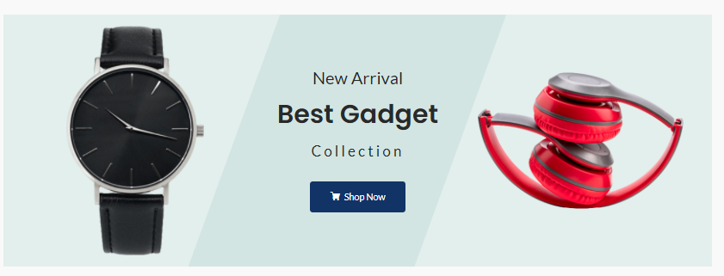

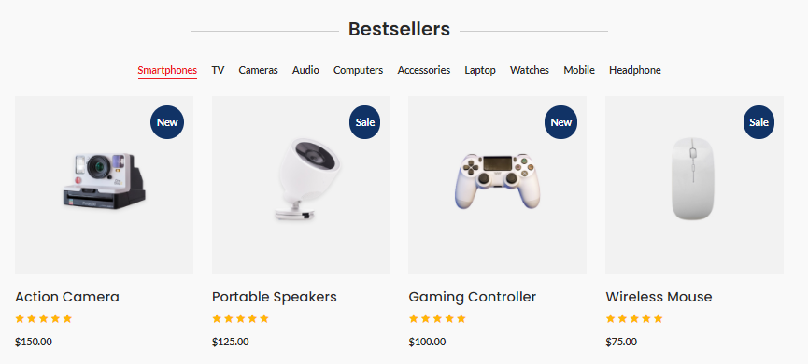

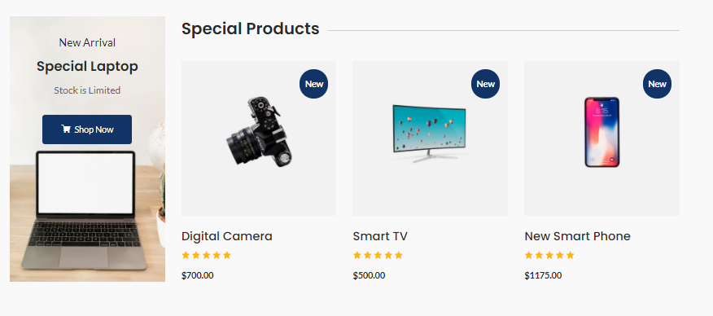

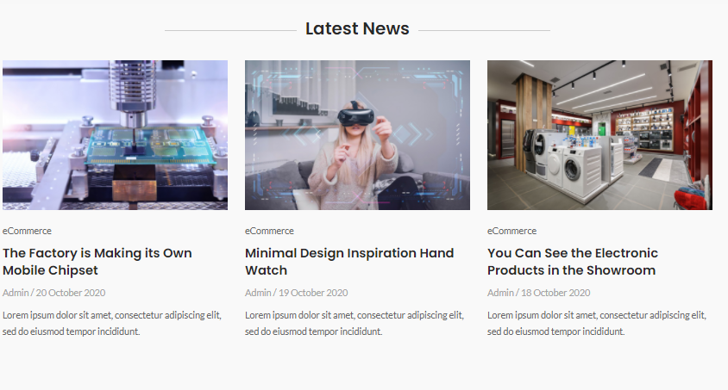

**Footer.php:**



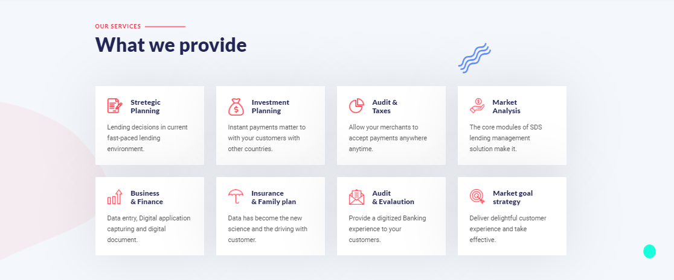

REPORT:

### 

### Admin:

|  |  |
| --- | --- |
| Total Number Of Adnin | 10 |
| No Of Present | 9 |
| No Of Absent | 1 |

### User:

|  |  |
| --- | --- |
| Total Number Of USERS | 500 |
| No Of Orders | 463 |
| Returned | 17 |
| No Of Replaced | 20 |

**CODE NIPPETS:**

index.php:

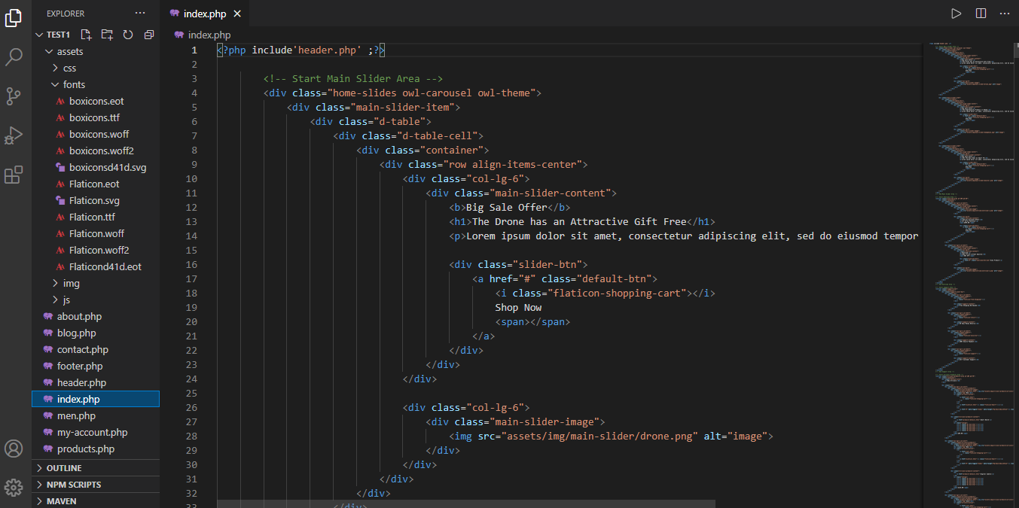

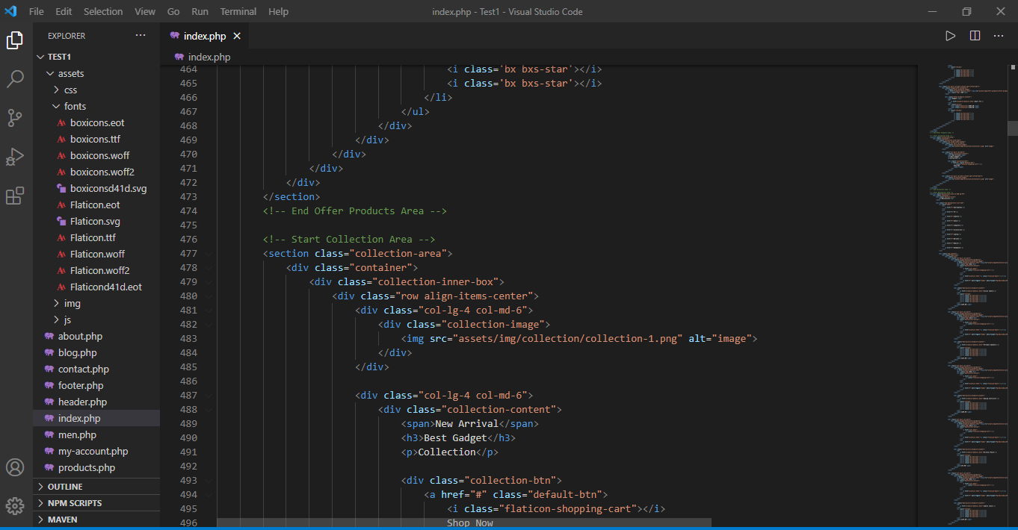

Header .php:

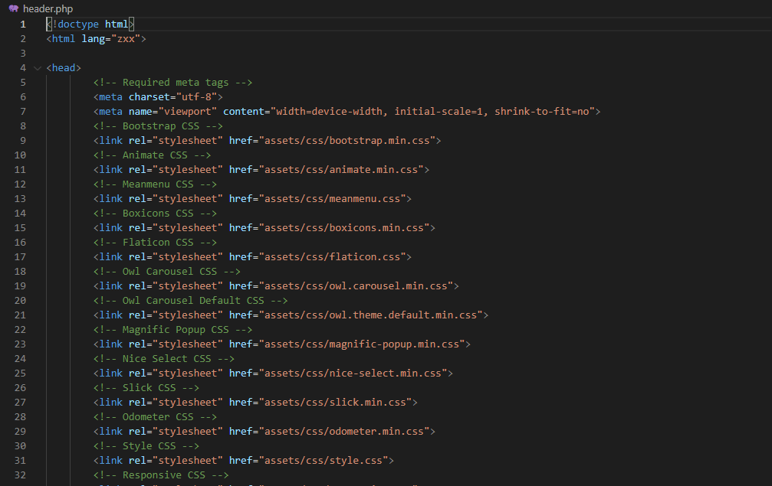

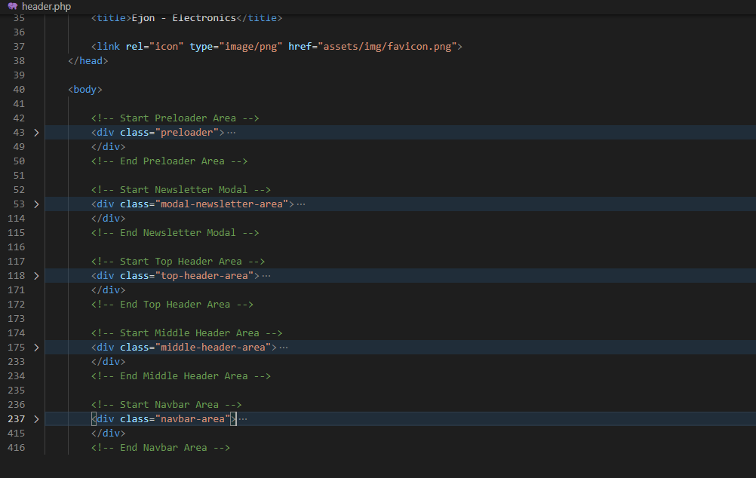

Footer.php:

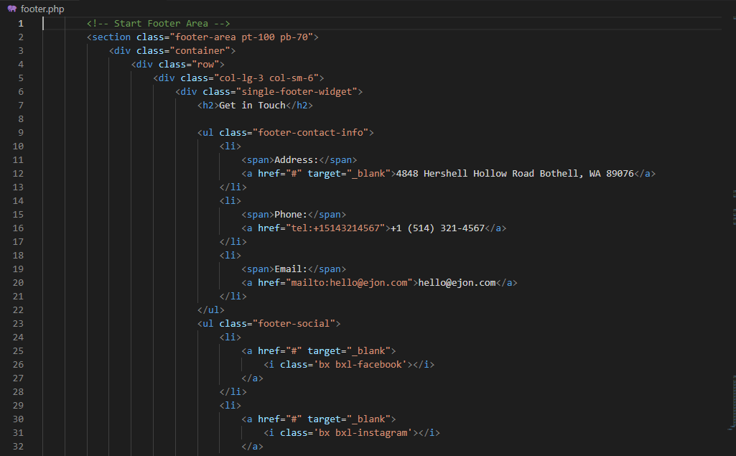

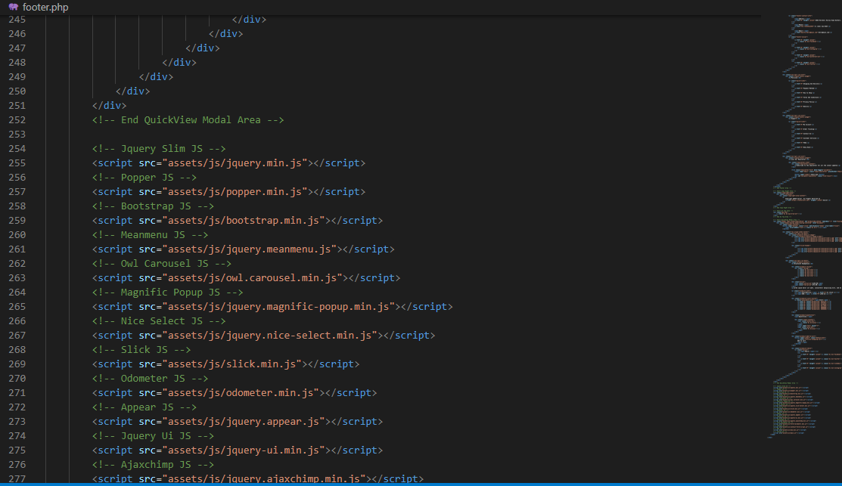

Men.php

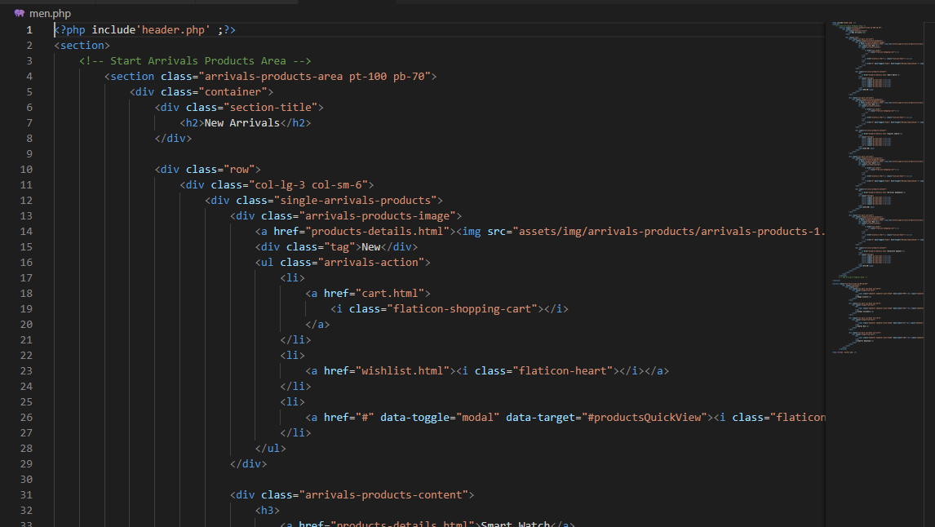

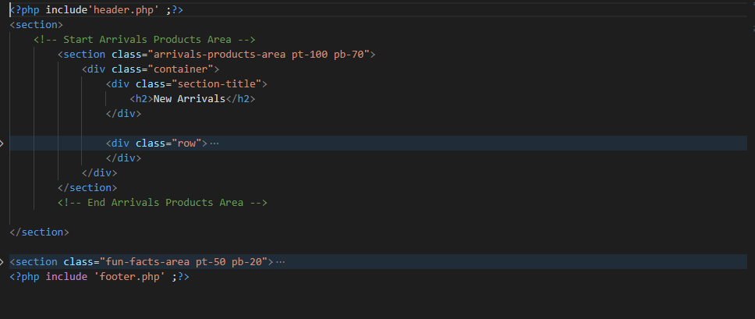

My-account.php:

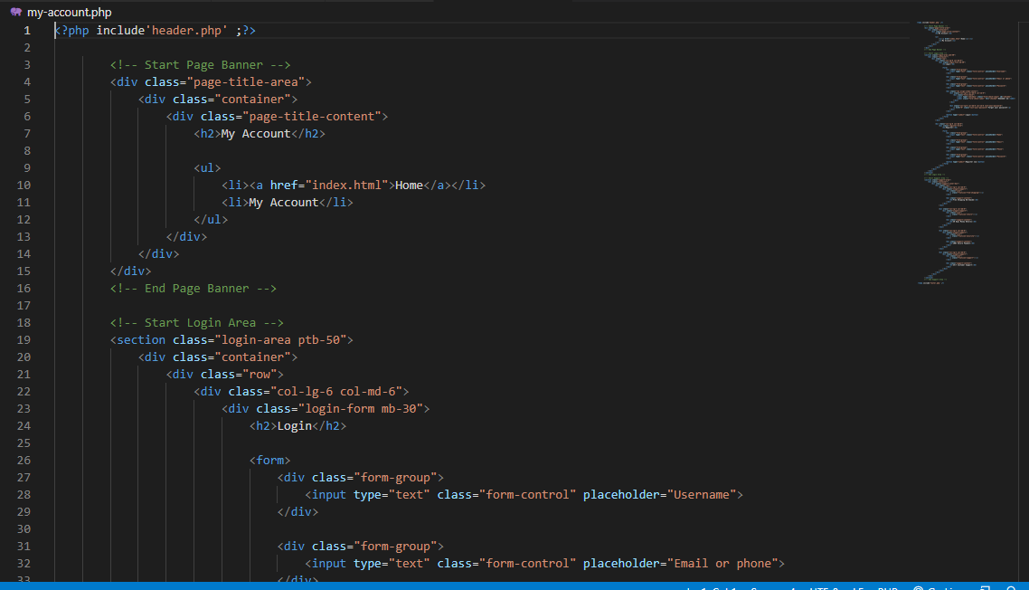

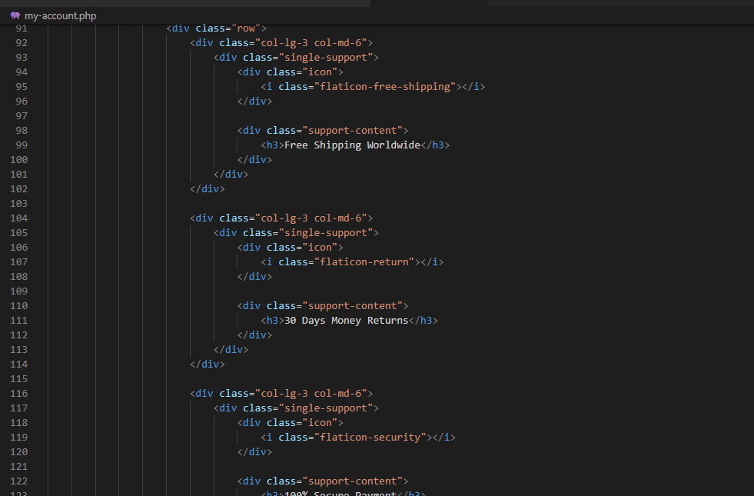

Contact.php:

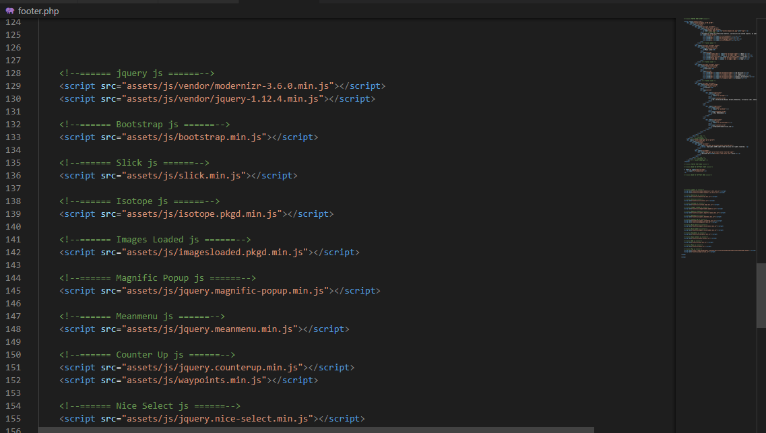

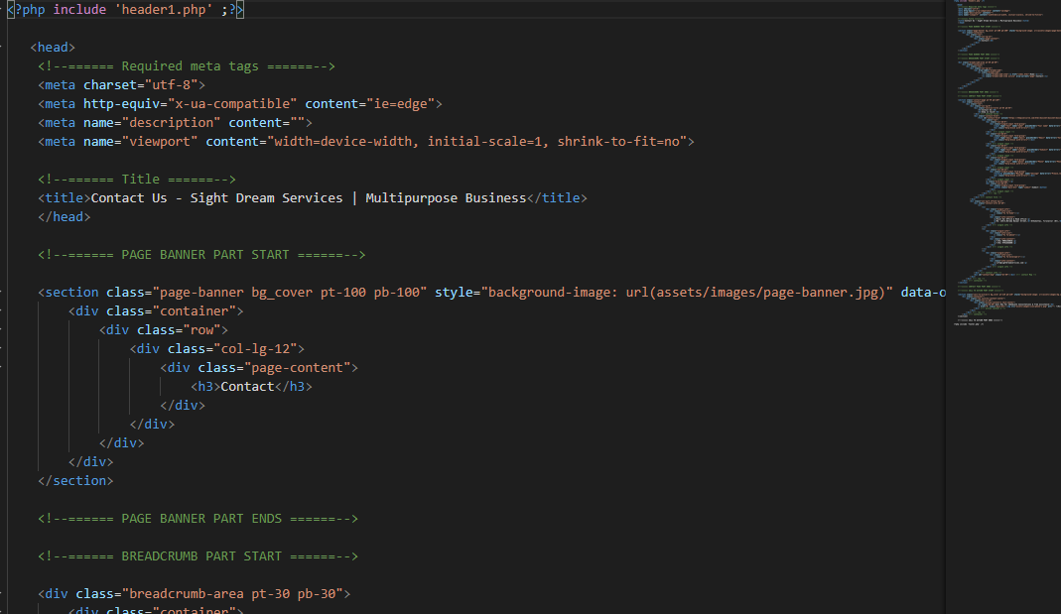

Pricing.php:

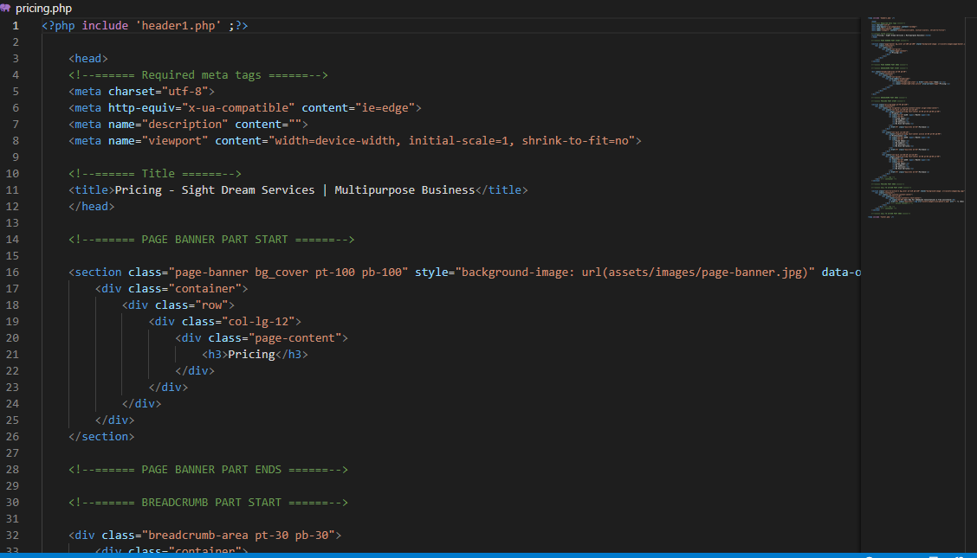

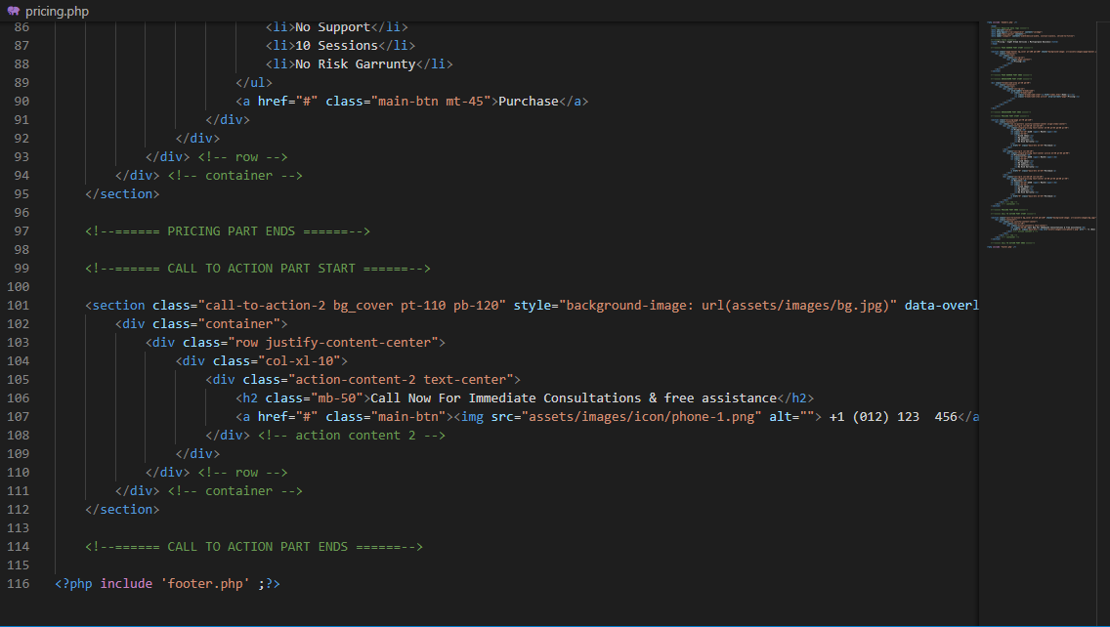

**Pricing.php:**

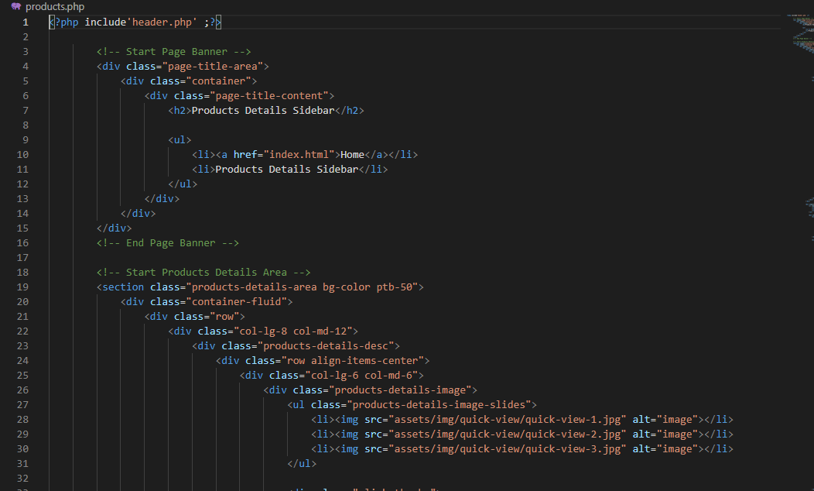

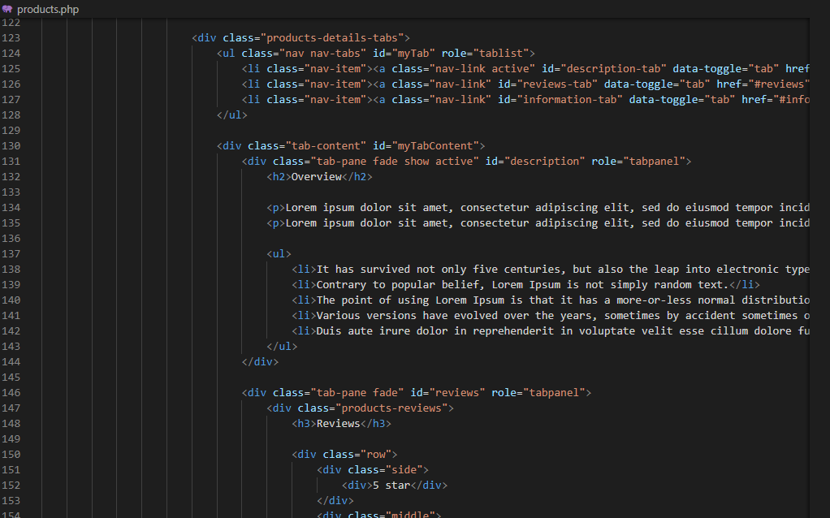

**Blog.php**

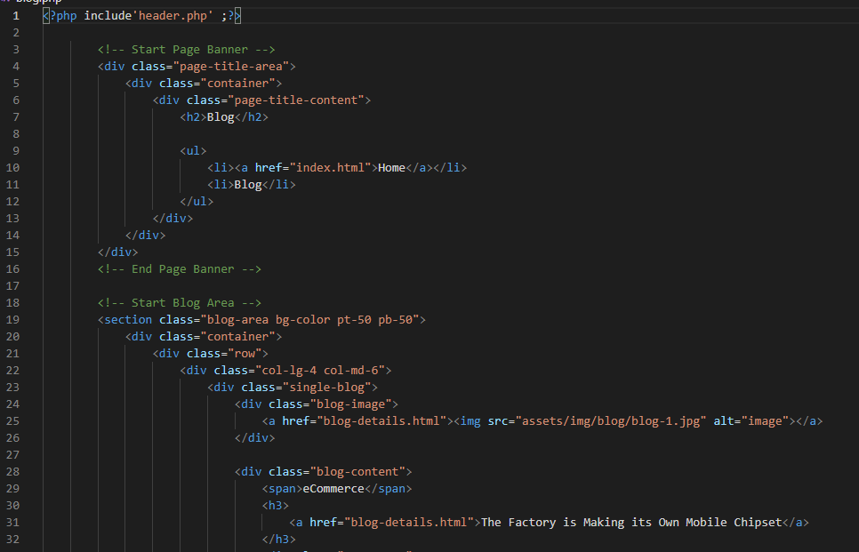

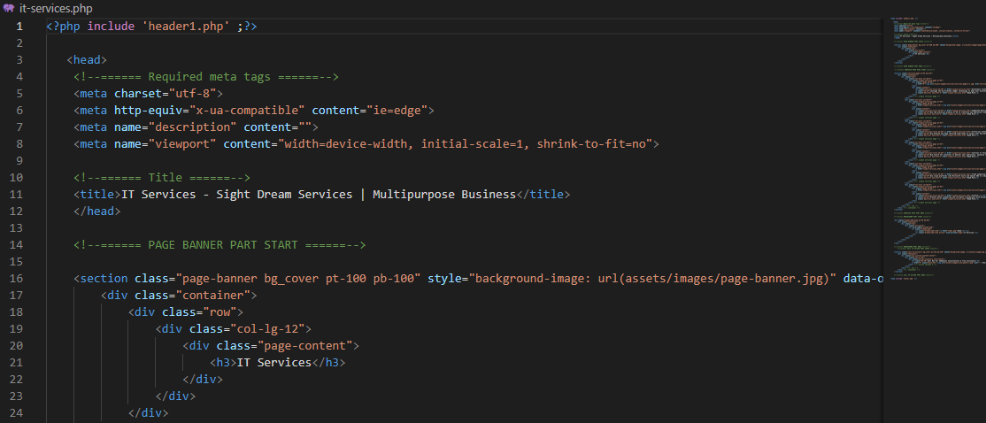

**About.php:**

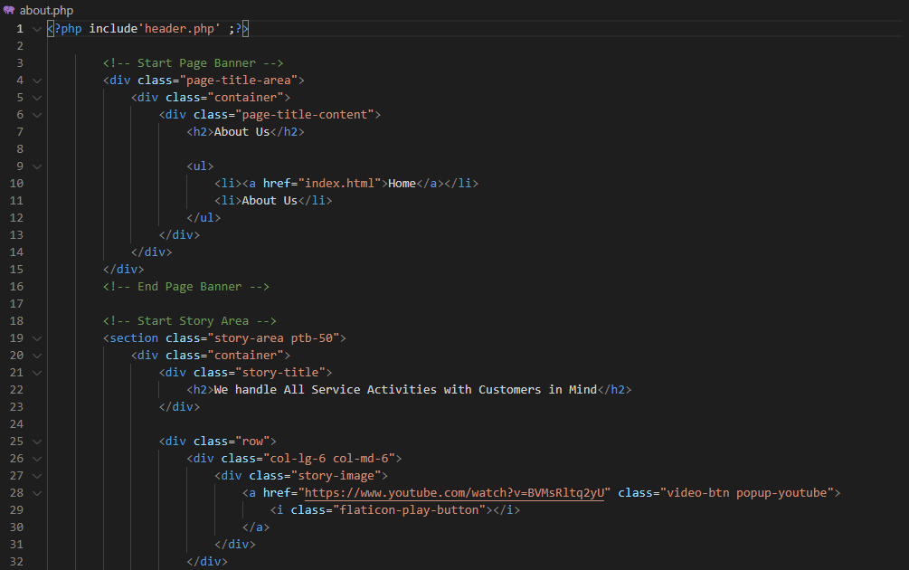

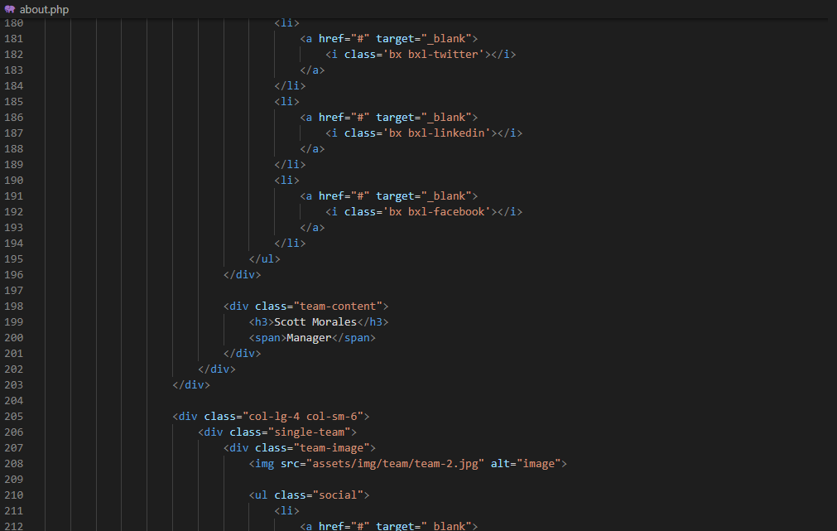

**Products.php**

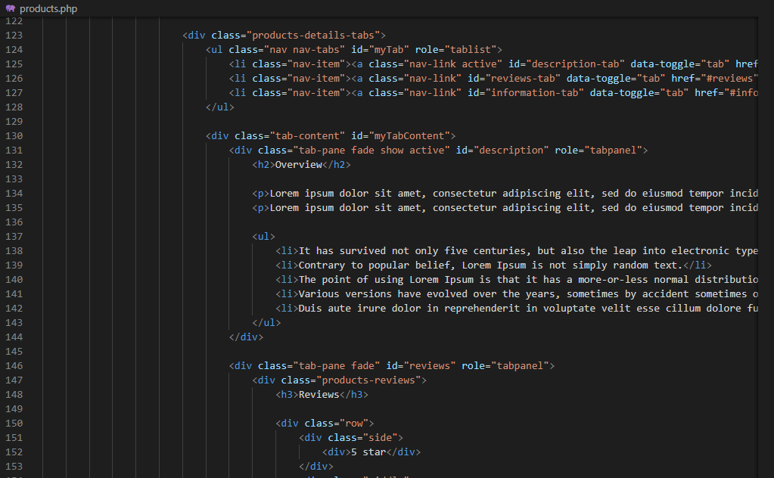

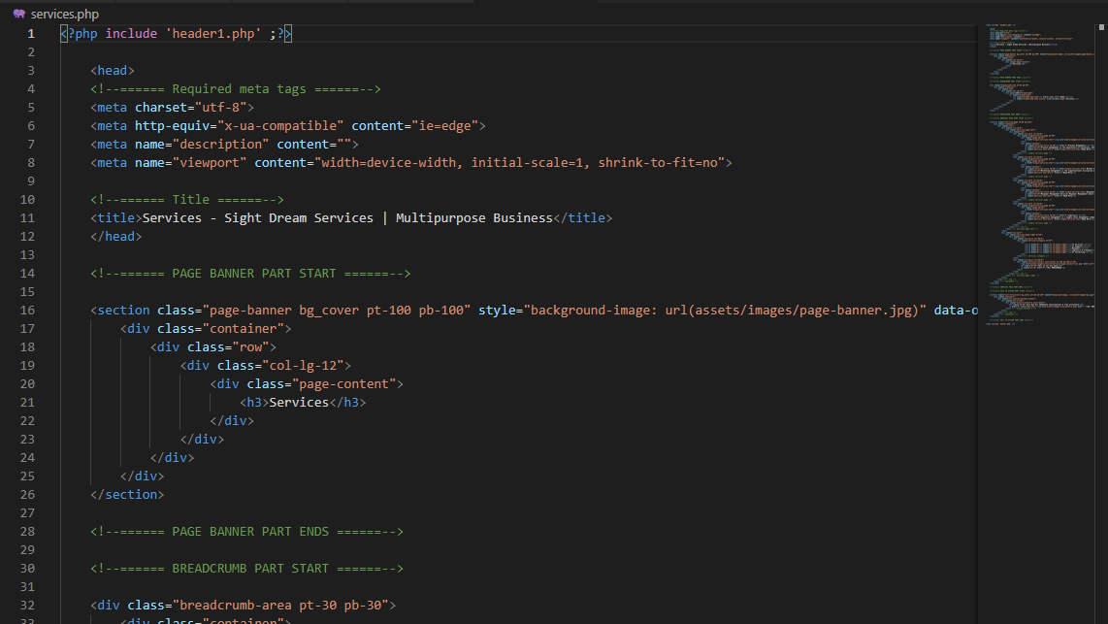

System Testing:

##### **SYSTEM TESTING**

**System testing** of software or hardware is testing conducted on a complete, integrated system to evaluate the system's compliance with its specified requriements. System testing falls within the scope of blackbox tesing and as such, should require no knowledge of the inner design of the code or logic.

As a rule, system testing takes, as its input, all of the "integrated" software components that have passed unit testing and also the software system itself integrated with any applicable hardware system(s). The purpose of integration testing is to detect any inconsistencies between the software units that are integrated together or between any of the *assemblages* and the hardware. System testing is a more limited type of testing; it seeks to detect defects both within the "inter- assemblages" and also within the system as a whole.

They performed on the entire system in the context of Functional

Requirements Specification(s) (FRS) and/or a System requirements Specification (SRS). System testing tests not only the design, but also the behaviour and even the believed expectations of the customer. It is also intended to test up to and beyond the bounds defined in the software/hardware requirements specification.

##### Basics of system testing

There are two basics of software testing: blackbox testing and whitebox testing.

##### Blackbox Testing :

Black box testing is a testing technique that ignores the internal mechanism of the system and focuses on the output generated against any input and execution of the system. It is also called functional testing.

##### Whitebox Testing:

White box testing is a testing technique that takes into account the internal mechanism of asystem. It is also called structural testing and glass box testing.

##### Types of testing

There are many types of testing like

Unit Testing Integration Testing Functional Testing System Testing Stress Testing Performance Testing Usability

Beta Testing

##### Unit Testing

Unit testing is the testing of an individual unit or group of related units. It falls under the class of white box testing. It is often done by the programmer to test that the unit he/she has implemented is producing expected output against given input.The design of the test cases the that validate that the internal program logic is function properly and the program gives the valid output . All decision branches and a internal code followed should be validated. It the testing of individual software units of the application is done after completion it individual unit before integration. This is structural testing, that relies on knowledge of its construction and its invasive. Unit tests performance basics test at component level and test a specific business process, application. and/or system configuration. Unit test ensure that each unique each path of a business process performs accurately to the documented specifications and contains clearly defined inputs and expected results.

##### Integration testing

Integration testing is testing in which a group of components are combined to produce output. Also, the interaction between software and hardware is tested in integration testing if software and hardware components have any relation. It may fall under both white box testing and black box testing.

##### Functional Testing

Functional testing is the testing to ensure that the specified functionality required in the system requirements works. It falls under the class of black box testing. This provide systematic Demostrations that functions are tested are available as specified by the business and technical requirements system documentation, and user manuals,

Functional testing is centered on the following items:

Valid Input : Identified classes of valid input must be accepted. Invalid Input : Identified classes of valid input must be rejected. Functions : Identified functions must be exercised.

Ouput: Identified classes of application must be exercised. System/Procedures : Interfacing system or procedures must be invoke.

**System Testing**

System testing is the testing to ensure that by putting the software in different environments (e.g., Operating Systems) it still works. System testing is done with full system implementation and environment. It falls under the class of black box testing.Its ensure that the entire integrated software system meets requirements . Its tests a configuration to ensure know and predictable results . An example of sytem testing is the configuration oriented system integrated test . They bsed on process description and flows,emphasizing pre-drive process links and integration points .

##### Stress Testing :

Stress testing is the testing to evaluate how system behaves under unfavorable conditions.

Testing is conducted at beyond limits of the specifications. It falls under the class of black box testing**.**Stress testing is the process of determining the ability of a computer, network, program or device to maintain a certain level of effectiveness under unfavorable conditions. The process can involve quantitative tests done in a lab, such as measuring the frequency of errors or

system crashes. The term also refers to qualitative evaluation of factors such as availability or resistance to denial-of-service (DoS) attacks. Stress testing is often done in conjunction with the more general process of performance testing. Stress testing is the process of determining the ability of a computer,network,program or device to maintain a certain level of effectiveness under unfavorable conditions. The process can involve quantitative tests done in a lab, such as measuring the frequency of errors or system crashes. The term also refers to qualitative evaluation of factors such as availability or resistance to denial-of-service (DoS) attacks. Stress testing is often done in conjunction with the more general process of performance testing .

When conducting a stress test, an adverse environment is deliberately created and maintained. Actions involved may include:

Running several resource-intensive applications in a single computer at the same time Attempting to hack into a computer and use it as a [zombie](http://searchmidmarketsecurity.techtarget.com/definition/zombie) to spread [spam](http://searchmobilecomputing.techtarget.com/definition/spam)

Flooding a [server](http://whatis.techtarget.com/definition/server) with useless [e-mail](http://searchmobilecomputing.techtarget.com/definition/e-mail) messages

Making numerous, concurrent attempts to access a single [Web site](http://searchsoa.techtarget.com/definition/Web-site)

Attempting to infect a system with viruses, Trojans, [spyware](http://searchsecurity.techtarget.com/definition/spyware) or other malware.

##### Performance Testing

Performance testing is the testing to assess the speed and effectiveness of the system and to make sure it is generating results within a specified time as in performance requirements. It falls under the class of black box testing.Performance testing, a non-functional testing technique performed to determine the system parameters in terms of responsiveness and stability under various workload. Performance testing measures the quality attributes of the system, such as scalability, reliability and resource usage.

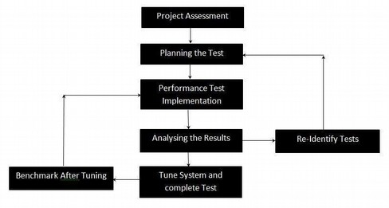

Performance Testing Techniques:

* **Load testing -**It is the simplest form of testing conducted to understand the behaviour of the system under a specific load. Load testing will result in measuring important business critical transactions and load on the database, application server, etc., are also monitored.
* **Stress testing -**It is performed to find the upper limit capacity of the system and also to determine how the system performs if the current load goes well above the expected maximum.
* **Soak testing -**Soak Testing also known as endurance testing, is performed to determine the system parameters under continuous expected load. During soak tests the parameters such as memory utilization is monitored to detect memory leaks or other performance issues. The main aim is to discover the system's performance under sustained use.
* **Spike testing -**Spike testing is performed by increasing the number of users suddenly by a very large amount and measuring the performance of the system. The main aim is to determine whether the system will be able to sustain the workload.

##### Usability Testing

Usability testing is performed to the perspective of the client, to evaluate is a technique used in user-centered interaction design to evaluate a product by testing it on users. This can be seen as an irreplaceable [usability](https://en.wikipedia.org/wiki/Usability) practice, since it gives direct input on how real users use the system.This is in contrast with [usability inspection](https://en.wikipedia.org/wiki/Usability_inspection) methods where experts use different methods to evaluate a user interface without involving users.

Usability testing focuses on measuring a human-made product's capacity to meet its intended purpose. Examples of products that commonly benefit from usability testing are foods, consumer\ products,web sites or web applications, computer interfaces, documents, and devices. Usability testing measures the usability, or ease of use, of a specific object or set of objects, whereas general [human-computer interaction](https://en.wikipedia.org/wiki/Human-computer_interaction) studies attempt to formulate universal principles.

##### Acceptance Testing :

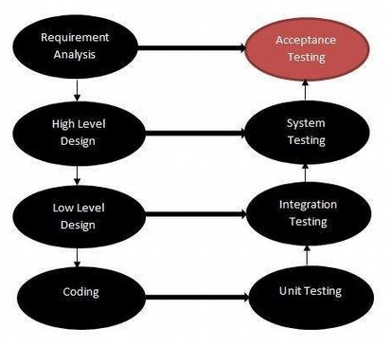Acceptance testing is often done by the customer to ensure that the delivered product meets the requirements and works as the customer expected. It falls under the class of black box testing.

Acceptance testing, a testing technique performed to determine whether or not the software system has met the requirement specifications. The main purpose of this test is to evaluate the system's compliance with the business requirements and verify if it is has met the required criteria for development of users.

The acceptance test cases are executed against the test data or using an acceptance test script and then the results are compared with the expected ones.

Acceptance Criteria

Acceptance criteria are defined on the basis of the following attributes Functional Correctness and Completeness

Data Integrity Data Conversion Usability Performance Timeliness

Confidentiality

Availability Installability and Upgradability Scalability

Documentation

##### Acceptance Test Plan -Attributes

The acceptance test activities are carried out in phases. Firstly, the basic tests are executed, and if the test results are satisfactory then the execution of more complex scenarios are carried out.

The Acceptance test plan has the following attributes: Introduction

Acceptance Test Category operation Environment Test case

Test Title

Test Objective Test Procedure Test Schedule Resources

The acceptance test activities are designed to reach at one of the conclusions: Accept the system as delivered

Accept the system after the requested modifications have been made Do not accept the system

Acceptance Test Report - Attributes

The Acceptance test Report has the following attributes: Report Identifier

Summary of Results Variations Recommendations Summary of To-DO List Approval Decision

##### Regression Testing

Regression testing is the testing after modification of a system, component, or a group of related units to ensure that the modification is working correctly and is not damaging or imposing other modules to produce unexpected results. It falls under the class of black box testing.

Regression testing is the process of testing changes to computer programs to make sure that the older programming still works with the new changes. Regression testing is a normal part of the program development process and, in larger companies, is done by code testing specialists. Test department coders develop code test scenarios and exercises that will test new units of code after they have been written. These test cases form what becomes the *test bucket*.

Before a new version of a software product is released, the old test cases are run against the new version to make sure that all the old capabilities still work. The reason they might not work is because changing or adding new code to a program can easily introduce errors into code that is not intended to be changed.

##### Beta Testing

Beta testing is the testing which is done by end users, a team outside development, or publicly releasing full pre-version of the product which is known as beta version. The aim of beta testing is to cover unexpected errors. It falls under the class of black box testing.In a test is the second phase of software testing in which a sampling of the intended audience tries the product out.

This test is also sometimes reffered to as user acceptance testing(UAT) or end user testing. In this phase of software development,applications are subjected to rel world testing by the intended audience for the software. The experiencesof the early users are forwarded back to the developers make final changes before relasing the software commercially.

**CONCLUSION:**

The electronic shop was developed using PHP, MySQL, HTML5 and CSS3 technology.

Any consumer can browse products, add, replace or delete a product from the cart.

The consumer can log in, with his information such as his email and password. If the logindoes not go through, the user can re-register or ask to change the password. After login, the user cansee the product in the cart and proceed onwards. The ordered price is saved in the database.

BIBLIOGRAPHY:

/1/www.w3school.com

/3/CSS3 characteristic and attributes 3.05.2018

/2/php features. 08.03.2018

http://www.biogem.org/downloads/notes/PHP%20- %20Hypertext%20Preprocessor.pdf

/4/Javascript academic. Accessed 09.03.2018

/4/http://www.w3schools.com/js/default.asp

<https://dev.mysql.com/doc/apis-php/en/apis-php-pdo-mysql.html>

/5/Documentation for mysql/ 05.01.2018

/6/UML idea. access 1.05.2018

https://en.wikipedia.org/wiki/Unified_Modeling_Language

/7/XAMPP 2.05.2018

https://www.apachefriends.org/index.html

/9/PhpMyAdmin. 5.05.2018

https://www.phpmyadmin.internet/

/8/Bracket editor 5.05.2018

https://en.wikipedia.org/wiki/Brackets_(text_editor)

/10/PayPal developer and Sandbox account 5.05.2018

<https://developer.paypal.com/developer/accounts/>

/11/The basic diagram of the HTML/HTML5 5/24/2018

Thank You Mam!!!